**DAILY ONLINE ACTIVITIES SUMMARY**

|  |  |  |  |  |  |  |  |  |
| --- | --- | --- | --- | --- | --- | --- | --- | --- |
| **Date:** | **22/05/2020** | | | | | **Name:** | **Arun K** | |
| **Sem & Sec** | **VI ‘A’** | | | | | **USN:** | **4AL17CS013** | |
| **Online Test Summary** | | | | | | | | |
| **Subject** | | **OR** | | | | | | |
| **Max. Marks** | | **30** | | **Score** | | | **30** | |
| **Certification Course Summary** | | | | | | | | |
| **Course** | **Python and Ethical hacking** | | | | | | | |
| **Certificate Provider** | | | **udemy** | | **Duration** | | | **1 month** |
| **Coding Challenges** | | | | | | | | |
| **Problem Statement:**  <https://github.com/ArunKumar9538/Alvas_onlione_coading/blob/master/README.md> | | | | | | | | |
| **Status: done** | | | | | | | | |
| **Uploaded the report in Github** | | | | | **yes** | | | |
| **If yes Repository name** | | | | | https://github.com/ArunKumar9538/Alvas_onlione_coading.git | | | |
| **Uploaded the report in slack** | | | | | **yes** | | | |

Online Test Details: (Attach the snapshot and briefly write the report for the same)

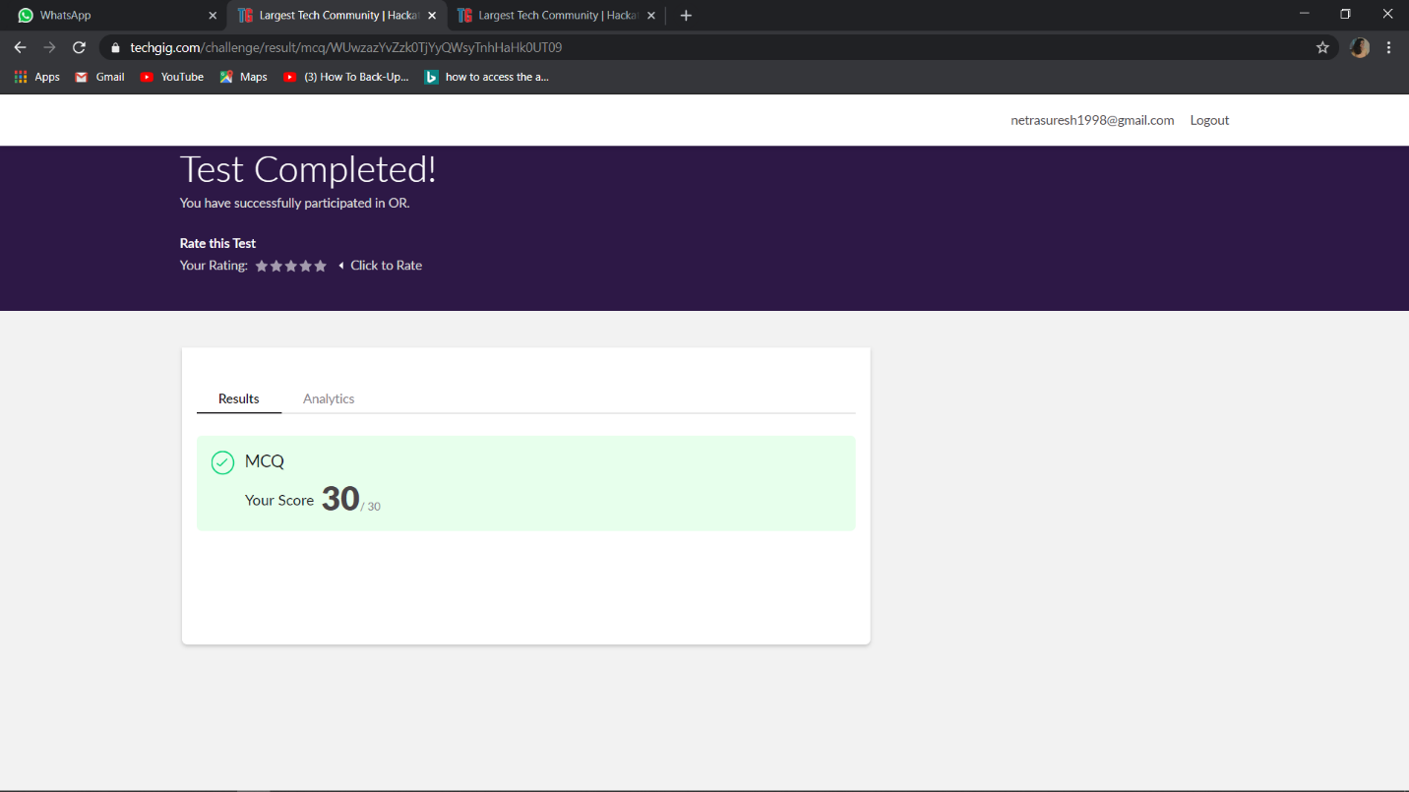

Certification Course Details: (Attach the snapshot and briefly write the report for the same)

Introduction about address resolution protocols, using module in python to create ARP request. Sending and receiving packets. Blue mark in screenshot is covered topic

